COMSATS University Islamabad

Attock Campus

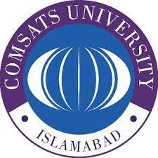

MAD

AHMED IKRAM RAO

(sp22-bse-049)

10 DEC, 2024

https://snack.expo.dev/@ahmedrao567/assign3

